**Assignment 4**

Write code and connection in wokwi for the ultrasonic sensor. Whenever

the distance is less than 100 cms send an “alert” to the IBM cloud and

display in the device recent events. Upload document with wokwi share link

and images of IBM cloud.

**OUTPUT:**

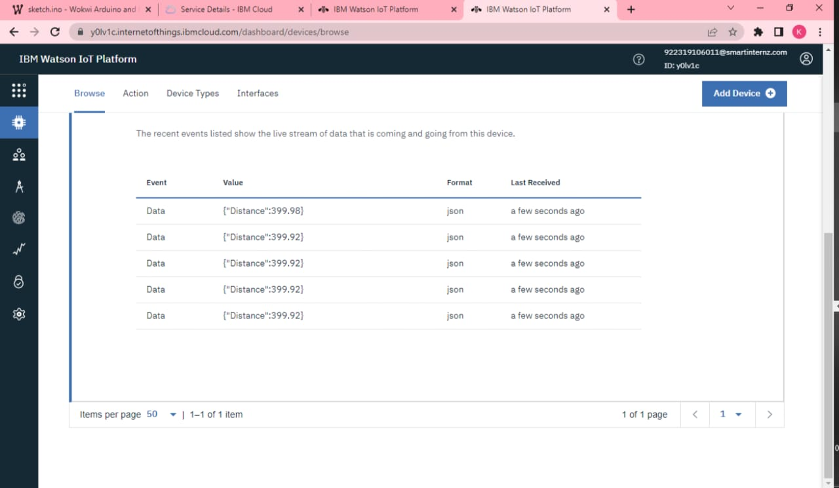

[**project link click here**](https://wokwi.com/projects/347827127708549716)